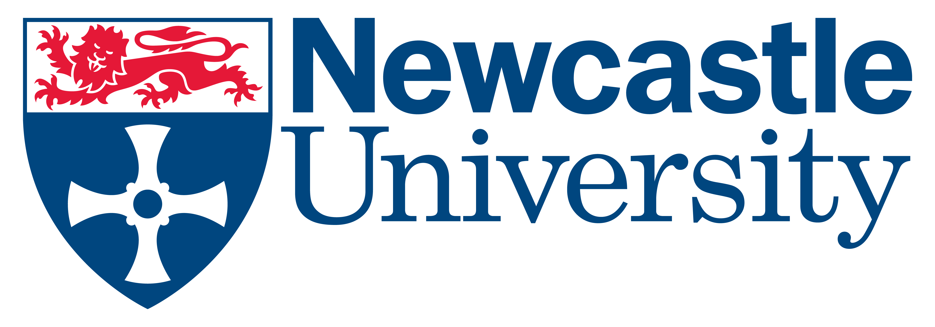‘Model Release Form’

NUIT – Digital Media Services
Newcastle University
Tel +44 (0) 191 208 7707

MPR number:………..

Print Name: (Block Capitals)………………………………………………………………..

Preferred name/title for name strap ………………………………………………………………

Work address/school ………………………………………………………………………
………………………………………………………………………………………………..
………………………………………………………………………………………………..
………………………………………………………………………………………………..
Email………………………………………………………………………………………….

I give consent for video recording (and the use of still frames from the video) to be made of me, for use as -

‘Promotional/teaching/general use’ including distribution by any physical or digital means in all printed materials, web sites and for use within/by Newcastle University.

I understand that the recorded media may be seen by the general public and that no attempt will be made to conceal my identity. All or part of the material may be used in conjunction with other photographs, drawings, videotape images, sound recordings or other forms of illustration.

Once released I realise that recovery of the recorded media may not be possible.
I understand that no fee is payable to me by Newcastle University or any other
person in respect of the material either now or at any time in the future.

I confirm that the purpose for which the recorded media may be used has been explained to me, in terms which I have understood.

To be completed by subject or parent/carer who has parental responsibility (if the subject is younger than 16 years)

I agree to the above statement

Signature (Model, or parent/guardian)…………………………………………

Date:…………………………………………

‘Model Release Form’

NUIT – Digital Media Services
Newcastle University
Tel +44 (0) 191 208 7707

MPR number:………..

Print Name: (Block Capitals)………………………………………………………………..

Preferred name/title for name strap ………………………………………………………………

Work address/school ………………………………………………………………………
………………………………………………………………………………………………..
………………………………………………………………………………………………..
………………………………………………………………………………………………..
Email………………………………………………………………………………………….

I give consent for video recording (and the use of still frames from the video) to be made of me, for use as -

‘Promotional/teaching/general use’ including distribution by any physical or digital means in all printed materials, web sites and for use within/by Newcastle University.

I understand that the recorded media may be seen by the general public and that no attempt will be made to conceal my identity. All or part of the material may be used in conjunction with other photographs, drawings, videotape images, sound recordings or other forms of illustration.

Once released I realise that recovery of the recorded media may not be possible.
I understand that no fee is payable to me by Newcastle University or any other
person in respect of the material either now or at any time in the future.

I confirm that the purpose for which the recorded media may be used has been explained to me, in terms which I have understood.

To be completed by subject or parent/carer who has parental responsibility (if the subject is younger than 16 years)

I agree to the above statement

Signature (Model, or parent/guardian)…………………………………………

Date:…………………………………………

